G-V1018A
Double Column Machining Center
Technology Agreement

Equipment technical description, parameters and configuration
- Equipment technical description
G-V1220A double column machining center is a large and medium-sized machine tool. The workpiece can automatically and continuously complete milling, drilling, boring, expanding, reaming, countersinking, tapping and other processes after one clamping. The machine tool is suitable for large processing of various types of small and medium-sized batches of complex parts such as medium-sized boxes, plates, disks, valves, and shells.
- The whole machine structure is a double column structure, with integrated columns and beams designed to improve the overall rigidity of the columns. The basic large parts are made of high-quality resin sand molding and high-strength cast iron materials to ensure high rigidity and stable accuracy of the machine tool. The main castings have undergone finite element analysis, and the ribs are reasonably arranged to fully meet the needs of high-torque cutting of machine tools.
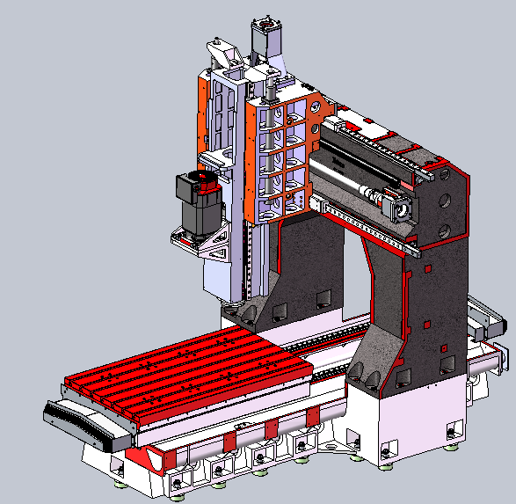
- High-speed belt-driven BT50-6000rpm spindle, provide high cutting efficiency.
- The front end of the spindle adopts a labyrinth design, and the spindle has an air curtain protection function to prevent cutting fluid from entering the spindle bearing.
- The spindle has central air blowing function and is equipped with an automatic circulating water cooling device to stabilize temperature and prevent thermal deformation of the spindle and maintain high machining accuracy.
- The main spindle box movement (Z-axis) is equipped with a nitrogen balance device. Even when moving at high speed, the counterweight will not shake; the precise ratio of the counterweight to the main spindle box weight can obtain the best processing characteristics, and the Z-axis drive motor has Good load characteristics.
- The three-axis feed adopts a direct connection drive method between the motor and the high-precision ball screw. The large-diameter ball screw is pre-stretched and installed to further improve the transmission rigidity and positioning accuracy.
- The Y-axis guideways adopt MSR55LS roller guideways respectively. The X/Z-axis guideways adopts MSR45LS roller guideways, which have high rigidity, low friction, low noise, strong shock resistance, and can carry greater cutting forces.
- The guide-ways and ball screws of the machine tool adopt a timed and quantitative lubrication system, which can adjust the oil supply cycle and amount of each lubrication point, and realize fully automatic centralized lubrication through electrical system control.
- The chip removal of the machine tool adopts double screw conveyor, which is automatic, user-friendly and high-efficiency. It is also equipped with a front chain plate chip conveyor, which greatly reduces manual cleaning time.
- The machine tool water tank adopts a multi-layer filtration system structure to provide good cutting fluid for workpiece processing.
- The machine is equipped with a high performance FANUC 0i-MF PULS (5) CNC system, which ensures the stability of the machine control, and also ensures the CNC machining function and auxiliary function required by the user.
- working conditions
- Power supply: three-phase AC 380V±10%; 50Hz±1Hz; the machine tool should have reliable grounding: the grounding wire is a copper wire ≥16mm²; the grounding resistance is <4Ω.
- In order to keep the static accuracy of the machine tool within the guaranteed value range, the machine tool should be installed in an area not affected by air flow. It is necessary to keep the surrounding temperature between 17℃~25℃, the humidity between 40% and 75%, and The ambient temperature change within 24 hours should be within ±2°C, and the ambient temperature change from the ground to about 5 meters high should be maintained within 2°C.
- If the requirements for the parts being processed are not high, the ambient temperature range can be relaxed to 10°C ~ 40°C.
- Keep away from light sources, vibration sources and heat sources, and away from high-frequency generators, discharge motors, welding machines, etc. to avoid electrical interference that may cause the machine tool NC system to malfunction.
- If the voltage in the area where it is used is unstable, the machine tool should be equipped with a regulated power supply to ensure the normal operation of the machine tool.
- In order to ensure the normal operation of the equipment, if the compressed air source does not meet the cleanliness requirements, an air source purification device (dehumidification, oil removal, filtration) should be added before the air intake of the machine tool.
- In order to maintain the accuracy and stability of the machine tool, the foundation must be made strictly in accordance with the requirements of the foundation diagram provided by the company.

2. Technical specification and configuration
2.1 Basic parameters
Item |  |  | Unit | Parameters | Remark
Travel range | X axis |  | mm | 1800
Travel range | Y axis |  | mm | 1100（+100 tool changing stroke）
Travel range | Z axis |  | mm | 800
Travel range | Door width |  | mm | 1160
Travel range | Distance from spindle end face to worktable |  | mm | 100～900
Travel range | Distance from spindle center to column guide surface |  | mm | 474
Worktable | Size |  | mm | 1800*1000
Worktable | Max. load  Workbench load-bearing |  | kg | 3000
Worktable | T-shaped slot (number of slots-slot width*spacing) |  | mm | 7-22*140
Spindle | Motor power (rated/short time) |  | kW | 15/18.5
Spindle | Spindle torque (rated/short time) |  | N▪m | 191/315
Spindle | Spindle speed |  | r/min | 50～6000
Spindle | Spindle diameter |  | mm | Φ210
Spindle | Tool holder specifications |  |  | BT50
Spindle | Pull stud |  |  | P50T-I（MAS403）
Guideways | X-axis |  | mm | 2-45 Roller
Guideways | Y axis |  | mm | 2-55 Roller
Guideways | Z axis |  | mm | 2-45 Roller
Drive | Ball screw X/Y/Z |  | mm | 50*12/50*12/50*12
Drive | Servo motor power X/Y/Z |  | kW | 3/3/3
Speed | Cutting feed speed range |  | mm/min | 1-10000
Speed | X/ Y/ Z axis rapid speed |  | m/min | 16/16/12
Precision | Position accuracy(X/Y/Z) |  | mm | 0.015/0.012/0.012
Precision | Repeatability (X/Y/Z) |  | mm | 0.008/0.008/0.008
Tool magazine (optional) | Tool magazine capacity |  | 把 | 24
Tool magazine (optional) | Max. tool weight |  | kg | 18
Tool magazine (optional) | Tool length |  | mm | 350
Tool magazine (optional) | Max. diameter (full /adjacent empty) |  | mm | Φ110/Φ200
Other | Z-axis counterweight |  | Other | Nitrogen balance
Other | Control system |  |  | FANUC 0i-MF PULS (5)/β motor
Other | Air | Flow | L/min | 280（ANR）
Other | Air | Air pressure | MPa | 0.5∼0.8
Other | Total power capacity |  |  | 40
Other | Cooling box volume |  | L | 400
Other | Machine tool appearance dimensions |  | mm | 4500*4250*3900 | Corresponds to X*Y*Z axis

2.2 Equipment standard configuration
No. | Item | Quantity | Remark
1 | FANUC 0i-MF PULS (5)/β motor CNC system | 1
2 | Operation panel | 1
3 | Pneumatic system | 1
4 | Air gun | 1
5 | Automatic lubrication system | 1
6 | Spindle cooling system (water cooling) | 1
7 | Workpiece cooling system | 1
8 | Spiral chip conveyor | 2
9 | Full protection | 1 | No cap
10 | Three-color signal light | 1
11 | Lighting device | 1
12 | Basic installation kit | 1
13 | Operating foot pedal | 1
14 | Technical documents | 1
15 | Chain plate chip conveyor | 1

2.3 Optional configuration
No. | Item | Whether to choose | Remark
1 | Column height increase 200mm | □ | The distance between the spindle end face and the work surface is 300-1100 mm
2 | BT50-24T disc type tool magazine | □ | Taikan
3 | 2MPa center through coolant | □
4 | 3MPa center through coolant | □
5 | Coolant gun | □
6 | BT50 manual right-angle milling head (2000 r/min) manual head change/ release/ rotation | □ | Cannot process inclined surfaces
7 | Grating ruler | □ | Fagor
8 | Grating ruler | □ | Heidenhain
Note: If you select this configuration, please mark √ in the corresponding item box. This table only lists the main selected configurations. For other selected configuration items, please consult the manufacturer and fill in the blanks.

2.4 Brands of main parts of equipment
No. | Item | Brand | Precision level
1 | Control system | FANUC 0i-MF PULS（5） | High performance level
2 | Spindle unit | Taikan | High precision grade
3 | Spindle bearings | Japan NSK/Germany FAG | P4 level
4 | Three-axis bearings | Japan NSK/Germany FAG | P4 level
5 | Three-axis ballscrew | Taiwan PMI/HIWIN
6 | Three-axis linear guideways | Taiwan PMI/HIWIN /REXROTH/YINA | P（Precision grade）
7 | Automatic lubrication pump | Domestic
8 | Servo driver | Japan FANUC
9 | Main electrical components | French Schneider
10 | Main pneumatic components | Japan SMC

Note: The manufacturer reserves the right to replace the product with the same brand

3.Recommended oil and grease
Lubrication part | Name | Capacity | Trademark | Manufacturer recommendation | Remark
Hydraulic station | Hydraulic oil | 40L | No. 46 | Shell Tellus 46  Or Great Wall HF-2 46 | Replace it after 3 months of initial use; replace it every 6 months thereafter (optional)
Spindle water cooling machine | Antifreeze coolant | 15L |  | BASF (BASF): Gulishun G48;  Mobil: -45℃ antifreeze coolant | Replace every 3 months
Lubrication pump | Rail oil | 4L | 32#(winter)  68# (summer) | Shell Tonna T32 (<10 degrees)  T68 (>10 degrees)  Or the great wall  HG32 (<10 degrees)  HG68 (>10 degrees) | Refill when the oil level is below the minimum level line

